System Design

As projects grow, it gets harder to keep everything looking consistent, a design system solves this by giving use one source for reusable components.

# Designing YouTube

Direct upload to blob storage –

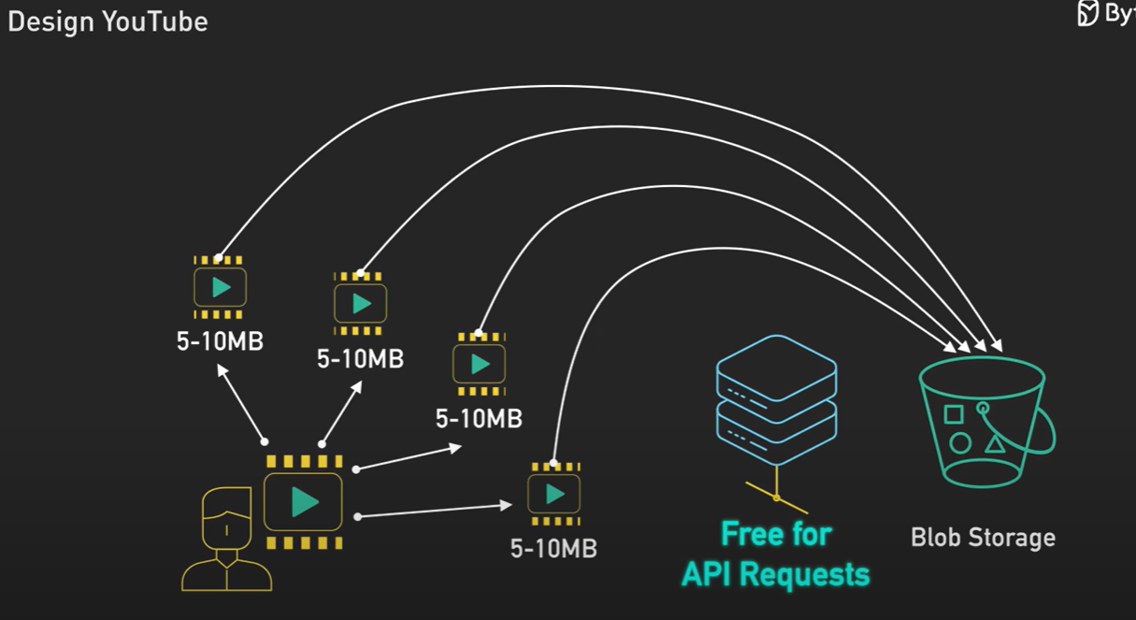

Using Parallel workflow instead of sequential –

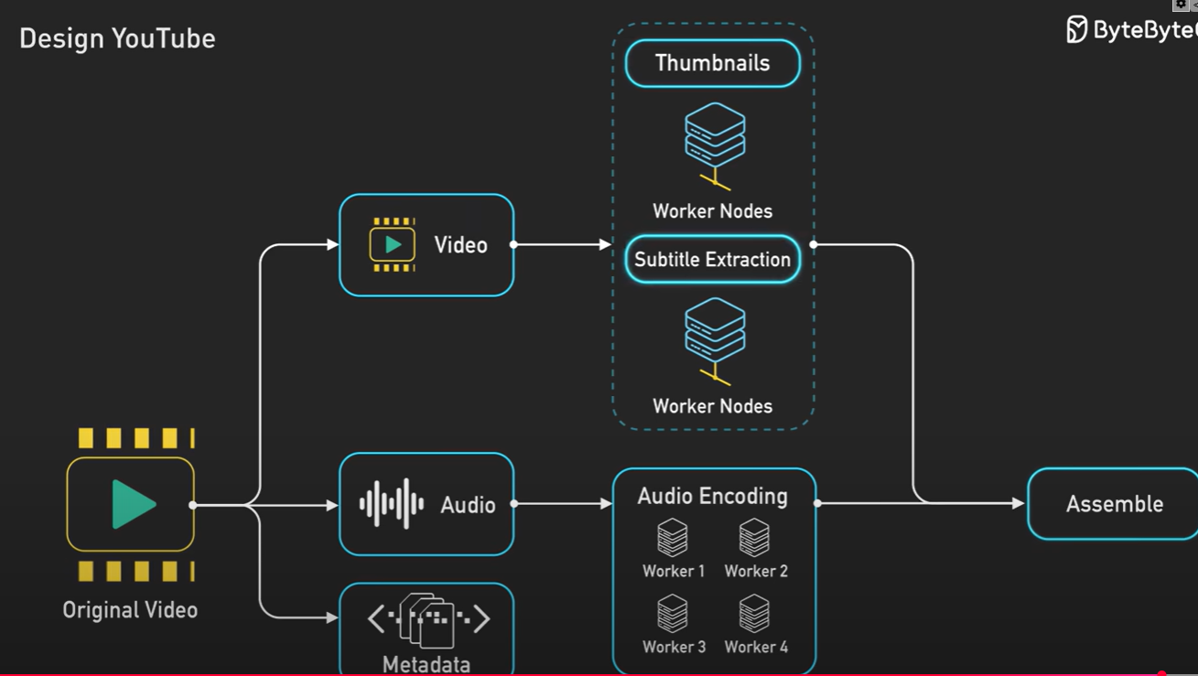

Adaptive streaming for smooth playback –

